Assignment 05
23F-3106
MUHAMMAD UMAR AFZAAL

TASK 1 A:

#include <iostream>
using namespace std;

class HashTable {
private:
int* table;
int capacity;
int itemCount;

public:
HashTable(int cap) {
capacity = cap;
itemCount = 0;
table = new int[capacity];
initializeTable();
}

~HashTable() {
delete[] table;
}

void initializeTable() {
for (int i = 0; i < capacity; i++) {
table[i] = -1;
}
}

void showTable() const {
cout << "\nHash Table Contents:\n";
for (int i = 0; i < capacity; i++) {
cout << "Slot " << i << ": ";
if (table[i] == -1) {
cout << "Empty";
}
else {
cout << table[i];
}
cout << endl;
}
}

void addItem(int value) {
if (itemCount >= capacity) {
cout << "Error: Hash table is full. Cannot insert " << value << ".\n";
return;
}

int position = value % capacity;
int originalPosition = position;

while (table[position] != -1) {
position = (position + 1) % capacity;
if (position == originalPosition) {
cout << "Error: Hash table is full. Cannot insert " << value << ".\n";
return;
}
}

table[position] = value;
itemCount++;
}
};

int main() {
HashTable hashTable(15);

hashTable.addItem(17);
hashTable.addItem(26);
hashTable.addItem(15);
hashTable.addItem(9);
hashTable.addItem(11);
hashTable.addItem(43);
hashTable.addItem(75);
hashTable.addItem(19);
hashTable.addItem(35);
hashTable.addItem(45);
hashTable.addItem(55);
hashTable.addItem(9);
hashTable.addItem(10);
hashTable.addItem(21);
hashTable.addItem(61);
hashTable.addItem(23);
hashTable.showTable();
return 0;
}

Output:
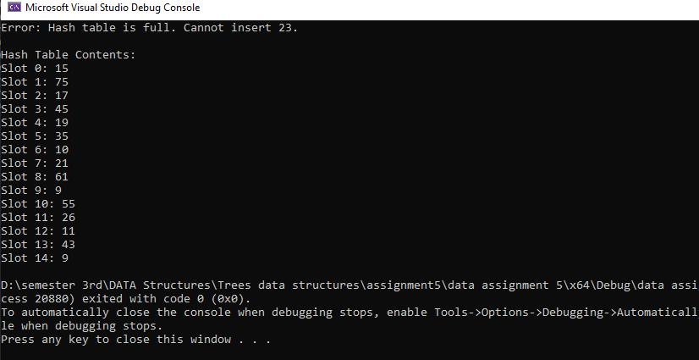

TASK 1 B:
#include<iostream>
using namespace std;

class HashTable {
private:
int* table;
int capacity;
int itemCount;

public:
HashTable(int cap) {
capacity = cap;
itemCount = 0;
table = new int[capacity];
initializeTable();
}

~HashTable() {
delete[] table;
table = NULL;
}

void initializeTable() {
for (int i = 0; i < capacity; i++) {
table[i] = -1;
}
}

void displayTable() const {
cout << "\nHash Table Contents:\n";
for (int i = 0; i < capacity; i++) {
cout << "Slot " << i << ": ";
if (table[i] == -1) {
cout << "Empty";
}
else {
cout << table[i];
}
cout << endl;
}
}

void insertItem(int data);
int getLoadPercentage(int itemCount);
int resolveCollisionWithDoubleHashing(int data, int pos);
};

// Get load percentage
int HashTable::getLoadPercentage(int itemCount) {
int percentage = (itemCount * 100) / capacity;
return percentage;
}

// Insert an item into the hash table
void HashTable::insertItem(int data) {
if (getLoadPercentage(itemCount) >= 70) {
capacity = capacity * 2;
int* tempTable = new int[capacity];

for (int i = 0; i < itemCount; i++) {
tempTable[i] = table[i];
}
for (int i = itemCount; i < capacity; i++) {
tempTable[i] = -1;
}

delete[] table;
table = tempTable;
}

int position = data % capacity; // Calculate hash position
if (table[position] != -1) {
position = resolveCollisionWithDoubleHashing(data, position);
}

table[position] = data;
itemCount++;
}

// Double hashing collision resolution
int HashTable::resolveCollisionWithDoubleHashing(int data, int pos) {
int offset = 1 + (data % (capacity - 1)); // hp(k)
int i = 1;
int finalPosition = (pos + i * offset) % capacity; // h(k) = [h(k) + i * hp(k)] % capacity

while (table[finalPosition] != -1) {
i++;
finalPosition = (pos + i * offset) % capacity;
}
return finalPosition;
}

int main() {
HashTable hashTable(15);

hashTable.insertItem(17);
hashTable.insertItem(26);
hashTable.insertItem(15);
hashTable.insertItem(9);
hashTable.insertItem(11);
hashTable.insertItem(43);
hashTable.insertItem(75);
hashTable.insertItem(19);
hashTable.insertItem(35);
hashTable.insertItem(45);
hashTable.insertItem(55);
hashTable.insertItem(9);
hashTable.insertItem(10);
hashTable.insertItem(21);
hashTable.insertItem(61);
hashTable.insertItem(23);

hashTable.displayTable();

return 0;
}

Output:
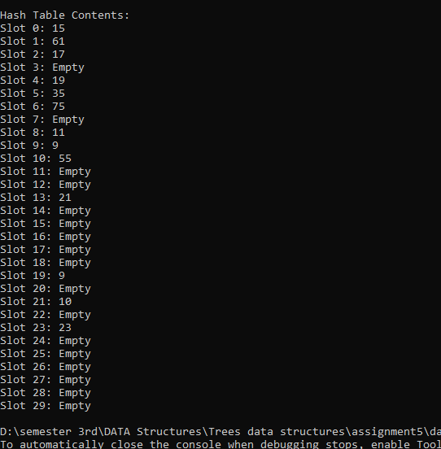

TASK 2 A:
#include<iostream>
using namespace std;
class node
{
public:
int data;
node* next;
node(int data)
{
this->data = data;
next = NULL;
}
};
class hashing
{
private:
node** arr;
int size;
public:
hashing(int size)
{
this->size = size;
arr = new node * [size];
for (int i = 0; i < size; i++)
{
arr[i] = new node(-1);
}
}

void insert(int data);
void display();
};
// Display
void hashing::display()
{
for (int i = 0; i < size; i++)
{
node* current = arr[i]->next;
cout << arr[i]->data << " -> ";
while (current != NULL)
{
cout << current->data << " -> ";
current = current->next;
}
cout << "NULL";
cout << endl;
}
}
// Insertion
void hashing::insert(int data)
{
int pos = data % size;
if (arr[pos]->data != -1)
{
node* current = arr[pos];
while (current->next)
{
current = current->next;
}
node* n = new node(data);
current->next = n;
}
else
{
arr[pos]->data = data;
}
}
int main()
{
hashing h(15);

h.insert(17);
h.insert(26);
h.insert(15);
h.insert(9);
h.insert(11);
h.insert(43);
h.insert(75);
h.insert(19);
h.insert(35);
h.insert(45);
h.insert(55);
h.insert(9);
h.insert(10);
h.insert(21);
h.insert(61);
h.insert(23);

h.display();

system("pause");
return 0;
}

Output:

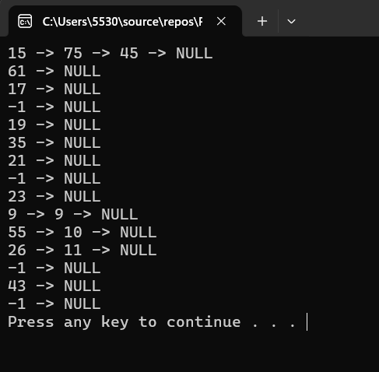

TASK 2 B:
#include<iostream>
using namespace std;
class hashing
{
private:
int** arr;
int size;
public:
hashing(int size)
{
this->size = size;
arr = new int* [size];
for (int i = 0; i < size; i++)
{
arr[i] = new int[size];
}

for (int i = 0; i < size; i++)
{
for (int j = 0; j < size; j++)
{
arr[i][j] = -1;
}
}
}

void insert(int data);
void display();
};
// OUtput
void hashing::display()
{
for (int i = 0; i < size; i++)
{
for (int j = 0; j < size; j++)
{
cout << arr[i][j] << " ";
}
cout << endl;
}
}
// inserting data
void hashing::insert(int data)
{
int pos = data % size;
if (arr[pos][0] != -1)
{
for (int i = 1; i < size; i++)
{
if (arr[pos][i] == -1)
{
arr[pos][i] = data;
return;
}
}
}
arr[pos][0] = data;
}
int main()
{
hashing h(15);

h.insert(17);
h.insert(26);
h.insert(15);
h.insert(9);
h.insert(11);
h.insert(43);
h.insert(75);
h.insert(19);
h.insert(35);
h.insert(45);
h.insert(55);
h.insert(9);
h.insert(10);
h.insert(21);
h.insert(61);
h.insert(23);

h.display();

system("pause");
return 0;
}

Output:
